SCFOA Hall of Fame Mission Statement

The SCFOA HOF is a non-profit entity chartered to give back to their community in an attempt to create a better society and enable future leaders through annual continuing education scholarships, awarded to those who have demonstrated the ability to positively impact their communities

High School Sports is the one of the biggest common denominators in leadership, responsibility, communication, and service. The Snohomish County Football Officials Association (SCFOA) is a group of community stewards who donate their time giving back to youth and students in greater Snohomish and King Counties. These officials have created a non-profit organization known as the Hall of Fame, which sponsors an event that recognizes scholar athletes within the area they service. These individuals are awarded with scholarships based on their abilities, not just on the field, but more for contribution within their communities. This event awards five scholarships to selected nominees from coaches and athletic directors. In an effort to grow and develop the annual SCFOA HOF Scholarship program, our association is hosting our 11th annual Golf Tournament to raise money to help increase these awards. We are really looking forward to making this a remarkable event and doing all we can to help scholar athletes throughout our region be successful in life.

With a goal of donating over $25,000 in scholarships this year, we need help from people and companies like you! Here are some of the ways you could help:

- A donation directly to the HOF towards the scholarship fund
- A sponsorship of a hole at the tournament
  - (4) Sponsorship levels available, details on the next page
- In-Kind donations of products or services for our raffle

DID YOU KNOW... Fun Facts about the SCFOA Hall of Fame!

- The HOF was formed in partnership with the SCFOA
- SCFOA HOF Serves 29 Schools throughout Snohomish County
- The HOF members volunteer with local youth football associations, lead coaches’ clinic and lead continuing education events for rule education
- 58 High School Seniors are nominated each year
- The HOF has doubled the scholarships in the last five years
- Over $300,000 has been awarded in scholarships
- In 2017 we awarded our first female scholarship
- HOF members serve the local community throughout the year working with organizations such as Housing Hope, Leadership Snohomish County, Toys for Tots, United Way

With our 501c3 non-profit organization status, your contributions would be tax deductible and 100% would go towards the youth athletes we serve. Our Non-Profit Corporation UBI # is 604 234 351 and our EIN is 82-5488850, if needed for tax purposes.

Mike Johnson Memorial
SCFOA Hall of Fames 11th Annual Golf Tournament Details

We are asking for tournament sponsors and in-kind donations:
The SCFOA Hall of Fame Scholarship Committee together with our presenting sponsor Shawn O’Donnell’s, are pleased to present our tenth annual golf tournament! We are really looking forward to making this a remarkable event. We have retained a wonderful venue- Legion Memorial Golf Tournament, and have a fantastic day planned! There will be 144 players who show up, not to mention all the staff and support. This year’s event will be on Friday, June 23rd.

Sponsorships for the Scholar Athlete Program are available at four levels. You will receive the following with this donation:

Platinum - $2,000.00:
- 4 Players, your choice of team
- Premium “Watering Hole” where you can personally greet players
ABOUT OUR PRESENTING SPONSOR

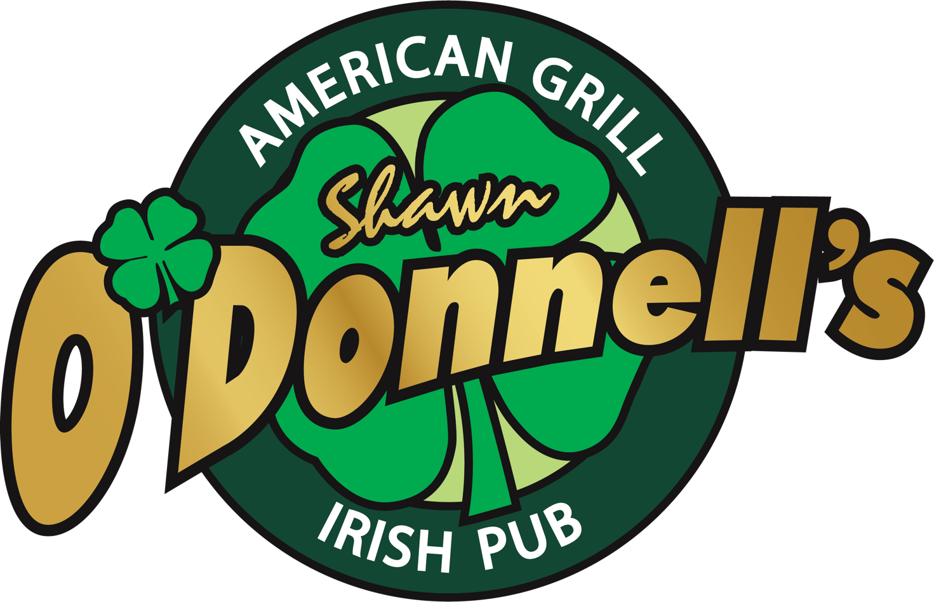
The HOF is grateful for the valuable partnership of our 2023 presenting sponsor Shawn O’Donnell’s. They are committed to our local community and support the HOF in all its endeavors. Charter sponsor, 9 years, donate all food for banquet and tournament as well as staff and time
O’Donnell’s is a local family owned and operated since 1987!

- Logo will be on player giveaways
- All marketing materials displayed with company logo
- Discounted foursome rate (if you would like additional players)
- Recognition at Award Ceremony
- Company banner displayed throughout event

Gold - $1,500.00:
- Twosome w/ discount for 2 additional players
- Premium “raffle” holes where you can personally greet all players
- All marketing materials displayed with company logo
- Discounted foursome rate (if you would like additional players)
- Recognition at Award Ceremony
- Company banner displayed throughout event

Silver - $1000.00
- Discounted foursome
- Yard sign placed at hole
- Recognition at Award Ceremony
- Company banner displayed throughout event

Bronze - $500.00
- Sign placed at hole
- Recognition at Award Ceremony
- Company banner displayed throughout event

It would be sincerely appreciated if you were able to help sponsor this event. As a benefit of your sponsorship, you will be able to reach and market to a large group within Snohomish County. We’ll allow any giveaway or name recognition paraphernalia to help boost your product or service.

Your support and donation are greatly appreciated. Thank you for helping make this event a success.

Joel Taylor
Committee Chair
425.327.4725

